Smart Attendance Management System

NAVYA ARORA, MAHIN MODI, SPARSH PHUTELA

Chandigarh University (CU)

GHARUAN Punjab, India

ABSTRACT

Smart Attendance Management System is an application designed for the daily presence of students in colleges or schools. This project attempts to record presence by face detection. The aim of this project is to develop a teacher management program software that can be used by all teachers in their subjects. The teacher will begin the process of being present by clicking on the classroom image. The algorithm used for face detection is Voila Jones. The software used to get faces in photos is MATLAB. The Gradients histogram is used to identify a feature. Also in partitioning the algorithm used Error Repair Coding using Vector Support Machine as a binary separator. The administrator maintains the website. Every day at the end the arrival is loaded into the system and intelligence can generate a list of those who do not pay.

- INTRODUCTION
Presence is defined as an act or condition of regular attendance or presence at a place or event. The presence of every student is maintained by schools and colleges. The personal record system does not work and extra time is needed to record and calculate each student's attendance. So a plan is needed that will solve the problem of personal presence. While advancing in the digital age is accelerating every hour, biometric technology has begun to impact daily human life. Biometrics technology uses features such as fingerprints, facial irises, retina patterns, palm printers, voice, handwritten signatures, and more for verification. These methods of using mobile data are increasingly being seen as an effective alternative to common security measures such as passwords or identity cards. Biometric personal verification uses data taken from measurements. Such data is unique to a person and remains the same throughout a person's life. It is important to identify the right tools to use in commercial and scientific studies. Barcode students, Radio Frequency Identification (RFID) system, Bluetooth and NFC (Near Field Communication) are just a few examples of such tools. However, they are expensive and therefore limited. A system that does not require special infrastructure is therefore developed using the Biometric Facial Detection and Recognition - Smart Attendance Management system.

System.

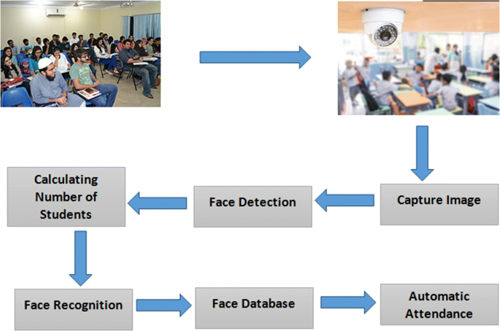

Fig.1 Smart Attendance Management System

- OVERVIEW

  - Existing System

The existing system mainly contains a visual register in which the administrator records the entry record of all students. Other technologies developed to replace this manual system include fingerprints, retina scan, voice recognition etc. The problem with the existing system is that the manual system is time consuming and advanced technology is too expensive to be used on a large scale in any way. organization.

- Proposed System

The following system eliminates the annoying task of keeping existing records by default. The supervisor completes the details of the teachers and students at the beginning of the semester. Class list is automatically generated. This information may be used for other seminars with minor modifications.

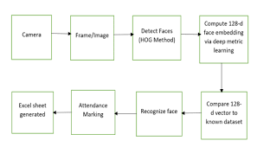

The system allows easy management using Face Detection, which is one of the most popular methods. The teacher needs to carry Digital Photography Devices to the classroom and take a picture of the class. The teacher then needs to log into the computer using his login details. A webpage provides a way to upload an image to a computer. The program has a copy of MATLAB installed on it. The system also contains a database that includes photos of all students and their personal details. The website also maintains accurate records of class teachers. After the image is uploaded to the program, the faces of the students are captured on the image using the MATLAB software. These images are then compared to student photos stored on the website using a face recognition algorithm and the attendance record is maintained. The computer then returns a copy of the html page to the teacher and to each student. But, what if only half of a student's face is visible or his or her face is blurred in the first image. The teacher can personally mark the presence of those students. This is how the record of attendance is maintained in our system.

  - THE PROPOSED SYSYTEM

- Block diagram

The block diagram of proposed system is as shown below
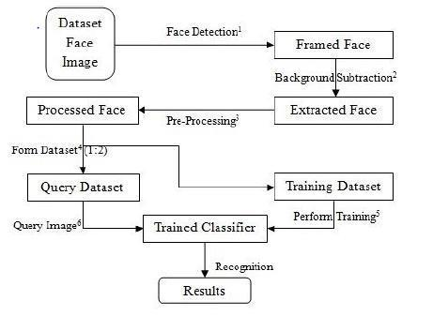
Jones algorithm which makes it a good detection algorithm are:

- Robust – very high detection rate (true-positive rate) & very low false-positive rate always.

- Real time – Processing must be at least 2 times per second for practical applications.

Face detection but not recognition - The goal is to differentiate faces from non-faces (face detection is the first step in the identification process)

The algorithm has mainly four main stages:

• Har Features Selection

• Creating Integral image

• Ad boost Training algorithm

- Cascaded Classifiers
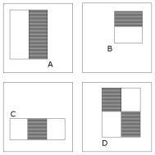

Fig.3 Feature types used by Viola and Jones

Advantages of Viola Jones algorithm:

• Extremely fast feature computation

Fig.2 Block diagram

B. Face Detection

The Viola Jones object detection framework to detect faces in the image. The main characteristics of Viola–
• Efficient feature selection

- Scale and location invariant detector

Disadvantages of Viola Jones algorithm:
• Detector is most effective only on frontal
images of faces

• It can hardly cope with 45° face rotation both
around the vertical and horizontal axis.

C. Face Recognition

Histogram of Oriented Gradient (HOG)

How to calculate the appearance of gradient shapes in local parts of an image. This

 | position. The HOG descriptor is therefore suited for
the method corresponds to the horizontal histograms, | human detection in images.
the adjacent element adjectives, and shapes, but differs | The final step in object recognition using Histogram of
in that it is calculated in a dense grid of evenly spaced
in that it is calculated in a dense grid of evenly spaced | Oriented Gradient descriptors is to feed the descriptors
cells and uses normal spatial brightness for improved
cells and uses normal spatial brightness for improved | into some recognition system based on supervised
accuracy [2]. First the face image is divided into
accuracy [2]. First the face image is divided into | learning. The Support Vector Machine classifier is a
smaller connected regions, called cells, and the | binary classifier which looks for an optimal hyper
horizontal histogram is calculated per computer over | plane as a decision function. Once trained on images
the pixels of a cell using an abstract mask such as | containing some particular object, the SVM classifier
Sobel masks. Each pixel in the cell will be the edge | can make decisions regarding the | presence of | an
Sobel masks. Each pixel in the cell will be the edge | object, such as a human being, in | additional | test
parameter and part of the gradient is attached to it, | object, such as a human being, in | additional | test
parameter and part of the gradient is attached to it, | images
thus calculating for the barrels. Histogram channels | images
are evenly distributed over 0–180 degrees or 0–360 | Error-correcting Output Coding (ECOC)
degrees, depending on the ‘unsigned’ or ‘signed’ | Error-Correct Extraction Code (ECOC) [1] is a
gradient. Histogram figures often compensate for the | compilation method designed for the problem of
gradient. Histogram figures often compensate for the | classification. In the case of multiple class divisions,
light. This process is performed by accumulating the
light. This process is performed by accumulating the | the task is a single label decision from the 2
amount of local histogram energy over larger
amount of local histogram energy over larger | possible options. For example, in the digital
connected regions and subsequently using the results
connected regions and subsequently using the results | detection function, we need to place a written
to make all block cells normal. The combination of | digital map of each hand in one of the classes k =
these histograms represents the final HOG definition. | 10. ECOC is a meta method that combines multiple
Flexibility in scale and rotation can also be achieved | binary categories to solve a multi-stage problem.
by removing adjectives from only the key points (key | Uses SVM (Support Vector Machine) binary
by removing adjectives from only the key points (key | classifier.
points) in the image scale space following the normal | classifier.
rotation. The steps involved are: | In machine learning, vector support devices
 | (SVMs, also support vector networks) are
• Extreme Scale-space discovery. | supervised learning models with associated
 | learning algorithms that analyse data and detect
• Assignment | patterns, which are used for editing and
• Assignment | retransmission analysis. Given a set of training
• Definition of the interpreter. An important idea
• Definition of the interpreter. An important idea | examples, each marked as part of two phases, the
behind the Histogram definitions of Oriented Gradient
behind the Histogram definitions of Oriented Gradient | SVM training algorithm creates a model that
definitions is that the appearance of the object and the
definitions is that the appearance of the object and the | provides new examples in one phase or another,
position within the image can be explained by the
position within the image can be explained by the | making it a viable binary line divider. The SVM
distribution of dynamic gradients or edge directions. | model is a model of models such as space points,
The application of these definitions can be achieved | drawn so that the models of the different categories
by dividing the image into smaller connected circuits, | are separated by a clear gap as wide as possible.
by dividing the image into smaller connected circuits, | New models are then mapped to the same space
called cells, with each cell comprising a histogram of
called cells, with each cell comprising a histogram of | and predicted to belong to a category based on
the directional or orientation of the pixels within the
the directional or orientation of the pixels within the | which side of the gap they fall into.
cell. The combination of tweetstorms then | which side of the gap they fall into.
represents the adjective. For improved accuracy, local
histograms can be simulated-standard by calculating
the degree of stiffness in a large image area, called a
block, and then using this number to make all the
normal cells within the block. This tendency leads to
better flexibility in light change or shade.
The HOG descriptor maintains a few key advantages
over other descriptor methods. Since the HOG
descriptor operates on localized cells, the method
upholds invariance to geometric and photometric
transformations, except for object orientation. Such
changes would only appear in larger spatial regions.
Moreover, as per the discovery of Dalal and Triggs,
coarse spatial sampling, fine orientation sampling, and | Fig.4 HOG Visualization
strong local photometric normalization permits the
individual body movement of pedestrians to be

METHODOLOGY

Having a video sequence as the input to the system the details of face detection, facial features extraction, normal-ization of facial features and quality score assignment are described in the following subsections.

A. Face Detection

For better accuracy of face-log generation, we employed face tracking technique. All we did was first detect the face using Viola & Jones idea as described in [9] and then, we used the correlation tracker from the dib library to keep track of the face from frame to frame. This approach also saves computational power since we don’t have to detect the face after transforming to a new frame in the real-time video sequence. This helps to generate a face-log i.e, a concise representation of the face of the subject in a video sequence [10].

- Parameters

  - Pose estimation: Since people move around and look

at different directions in front of the real-time camera, it is possible to have a wide range of head poses oriented at different angles. But for the sake of biometrics, it is important to have least rotated face as a standout in the entire face-log. Thus it is important to include this feature in face quality assessment. We determined the head pose using three angles: Roll, Yaw, Pitch. All these angles are typically between - 90 to + 90. The roll and pitch are adjusted by aligning technique during face-log generation, so our only concern is yaw angle. Using face landmarks detection, we calculated the coordinates
of nose tip and also the point between the eyebrows. If (x₁,
y₁) and (x₂, y₂) are such points, then yaw angle is computed as:

yaw =abs(arctan 2(y₂ − y₁, x₂ − x₁)) |  |  |  | (1)
TABLE I: Head-pose estimation
Range Of Yaw Angle | 0 to 10 | 10 to 20 | 20 to 30 | More than 30
NHP | 1 | 0.5 | 0.33 | 0.25

Then Normalized head-pose parameter (NHP) is obtained as shown in table,

- Sharpness: It is very likely to have blurry images in real time video sequences because the faces are moving. Thus it is important to include this feature in face quality assessment. To compute the sharpness of an image, we utilized the variance of an image Laplacian. This can be defined as:

where I is the mean value of image Laplacian within (x, y). We took a grey-scale channel of an image and convolved it with the (3x3) kernel and took the variance of that result.

 | 0 | 1 | 0
kernel = | 1 | −4 | 1 | (3)
 | 0 | 1 | 0

If the variance falls below a pre-defined threshold, then the image is considered as a blur. This threshold depends on the working environment and can be set accordingly. We then normalized it with a pre-defined threshold,

Normalized Sharpness(N S) = | Sharpness | (4)
Normalized Sharpness(N S) = | threshold | (4)

- Image size or resolution: Since we employed the face tracking technique, the camera tracks the face as long as the face is in the scene. But, as the face moves far away from the camera, there will be a large distance between the camera and the face. Thus, the size of the face becomes smaller. Thus, it is important to include this feature in face quality assessment. Using face landmark detection, we calculated the position of

the eye corners in a face. Let (xL, yL) be the coordinates of the

left eye corner and (xR, yR) be the coordinates of the right eye corner. The distance between them is given by:

Resolution = | (xL − xR)² + (yL − yR)² | (5)

Then we normalized the obtained resolution with the threshold for interocular distance as,

Normalized Resolution(N R) = | Resolution |  | (6)
Normalized Resolution(N R) = |  | threshold | (6)

Larger the distance, smaller will be the size of the face and hence, lesser will be the resolution.

TABLE II: Weights for various parameters in computing FQA

Parameter | Head-pose | Sharpness | Brightness | Resolution
Weight | 17 | 9 | 6 | 8

Sharpness = | ( I(i, j) − I )2 (2)
 | (i,j)∈ (x,y)

- Brightness: Changes in Lightening conditions are quite common in real-time applications like surveillance cameras. It is easier to apply Local feature extraction on brighter faces than on darker faces. Thus, it is necessary to include this feature in face quality assessment. To obtain this parameter, we calculated the mean of all the intensities of various channels (R, G, B) present in the image.

Brightness = (R + G + B)/3 | (7)
Normalized Brightness(N B) = Brightness/100 | (8)

C. Final Score

In order to get the best quality image in the real-time video sequence, we need to assign weights to each of the normalized parameters (NHP, NS, NR, NB). We gave the highest priority to the head pose followed by other parameters as shown in Table II. So, we computed the Face Quality Assessment (FQA) as,

FQA=NHP ×17+NS×9+NB×6+NR×8 (9)

Greater is the value of FQA, greater will be the quality of face which will be stored in Face-log. We can set the threshold for these FQA values of generated images to prevent the bad quality images from being stored in face-log.

D. Representation : Deep Learning

Face representation is the core of the recognition algorithm used in this system. The face image captured after the quality assessment is needed to be represented in form of feature for further processing. The preprocessed images are too high-dimensional for a classifier to take directly on input. To obtain a low-dimensional distinct feature from the face images we used Convolution Neural Network (CNN), popularly known as deep learning. A deep network is a feed-forward network comprising of many function compositions, or layers. The network is provided with a loss function L. The loss function measures how accurately the neural net-work classifies an image. Common layer operations repeated on the input image over the sequence of layers are:

- Spatial convolutions that slide a kernel over the input feature maps.

- Linear or fully connected layers that take a weighted sum of all the input units, and

- Pooling that takes the max, average, or Euclidean norm over spatial regions.

These operations are often followed by a nonlinear ac-tivation function, such as Rectified Linear Units (ReLUs) [11], which are defined by f (x) = max{0, x}. Neural

(a)
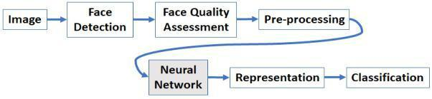
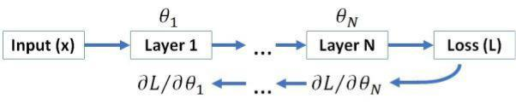

(b)

Fig. 1: (a) Pipe line of the system; (b) Block diagram of the deep neural network

network training is an optimization problem that finds a

- that minimizes (or maximizes) L. With differentiable

layers, L = θi can be computed with back-propagation. The optimization problem is then solved with a first-order method [12], which iteratively progress towards the optimal value

based on L = θi. Figure 1b shows the logic flow for face recognition with neural networks. The neural network predicts some probability distribution and the loss function L measures how well is the prediction close to the person’s actual identity.
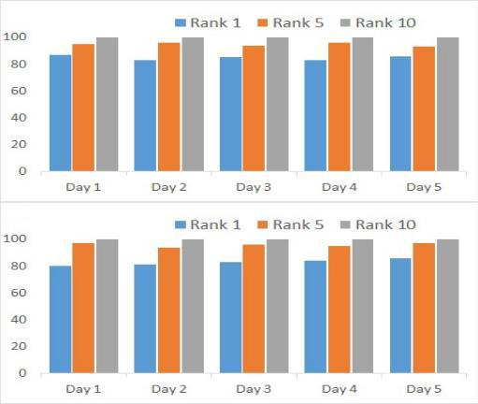

Fig. 2: Performance of SAMS for Classroom 1 and Class-room 2
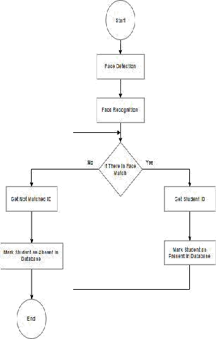

A Characteristics of the Proposed System

- User Friendly: The proposed system is very user friendly. The reason is the retrieval and storing of data is fast and data is maintained efficiently.

Furthermore the graphical user interface is provided in the proposed system, which provides user to deal with the system very comfortably.

- Reports are easily generated: Defaulter Reports can be generated very comfortably in the proposed system so that user can generate the report as per his/her requirement (monthly) or in the middle of the session. User can provide the notice to the students so as to be regular.

- No paper work: The proposed system does not require much paper work. All the data is fetched into the database immediately and reports can be generated very easily by the teachers. Furthermore work becomes very easy because there is no need to keep data on papers.

B Software Requirements

Operating System - Windows XP or higher (32 or 64 bit) Programming language – Python

C Hardware Requirements

Hardware components used for the making of SAMS are as follows.

- UDOO X86 Ultra Single Board Computer used for running the algorithms.

- 15MP Camera.

- Mini-keyboard.

- 7-inch LCD.

- Portable power bank and 5V to 12V DC converters

Any device which is capable of clicking a photo can be used, and the image can be used to mark the attendance of the class by accessing the online website.

D Steps In Project Development

The following steps were taken during the development of the proposed system:

- Defining the problem.

- Research about existing systems

- Developing the block diagram.

- Software development.

- Testing and debugging the code.

- Testing the entire system.

- Software release

- Documentation.

- PERFORMANCE OF THE SYSTEM

SAMS is designed to register individual faces for the first time. Once completed, the network automatically trains it for future use. In subsequent classes, students can navigate themselves through a GUI that provides a drop-down menu for known faces. This is because of the potential for similar looks in the classroom. The first word in the pull has a higher probability of similarity. We have stated this as the accuracy of Rank 1. With a closed game between 5 faces, we call it Rank 5. System performance is shown in Fig. 2.

IV. CONCLUSION

This project demonstrates marking and management in real-time presence. We have successfully implemented an application that not only helps the teacher attend but also assesses the number of students who attend. We have built a website for images from

write two classes. Website communication made in Java and a student attendance database is created in MS Access.

The default presence management system is intended

in resolving issues of manual methods of existing systems. We have used the concept of face recognition to use a system that marks the presence of a person by seeing and seeing faces. These systems work satisfactorily with different facial expressions, light and posture. There is room for improvement as these programs sometimes fail to see every student present in the classroom. We have made the device portable for easy use even with open sessions, without interrupting the classroom. There are future plans to create integrated ergonomics to make it an easy-to-use product to contribute to creating a healthier learning environment..

IV. APPLICATIONS

The proposed system as a wide range of applications, some of them are as follows:

- Time Attendance recording in offices

- Access control at office, Banks

- Canteen management & Food coupon system

- Visitor management

- Members management at event

VI. ENHANCEMENTS

The Facial recognition database can be improved by adding more images and variable poses of the students to make recognition full proof. The Web based architecture can be utilized further by maintaining the databases on a remote server and the application will be accessible via the Internet.

REFERENCES

- J. L. Epstein and S. B. Sheldon, “Present and accounted for: Improving student attendance through family and community involvement,” The Journal of Educational Research, vol. 95, no. 5, pp. 308–318, 2002.

- D. D. Ready, “Socioeconomic disadvantage, school attendance, and early cognitive development: The differential effects of school expo-sure,” Sociology of Education, vol. 83, no. 4, pp. 271–286, 2010.

- C. Bruner, A. Discher, and H. Chang, “Chronic elementary absen-teeism: A problem hidden in plain sight,” Attendance Works and Child & Family Policy Center, 2011.
- C. P. McCluskey, T. S. Bynum, and J. W. Patchin,

“Reducing chronic absenteeism: An assessment of an early truancy initiative,” NCCD news, vol. 50, no. 2, pp. 214–234, 2004.

- S. K. Jain, U. Joshi, and B. K. Sharma, “Attendance management system,” Masters Project Report, Rajasthan Technical University, Kota, 2011.

- V. Bhalla, T. Singla, A. Gahlot, and V. Gupta,

“Bluetooth based attendance management system,” International Journal of Innovations in Engineering and Technology (IJIET) Vol, vol. 3, no. 1, pp. 227–233, 2013.

- S. S. Mahat and S. Mundhe, “Proposed framework: College atten-dance management system with mobile phone detector,” International Journal of Research in IT and Management, vol. 5, no. 11, pp. 72–82, 2015.

- S. Joardar, A. Chatterjee, and A. Rakshit, “A real-time palm dorsa subcutaneous vein pattern recognition system using collaborative representation-based classification,” IEEE Transactions on Instrumen-tation and Measurement, vol. 64, no. 4, pp. 959–966, 2015.

- P. Viola and M. J. Jones, “Robust real-time face detection,” Interna-tional journal of computer vision,

vol. 57, no. 2, pp. 137–154, 2004.

- K. Nasrollahi and T. B. Moeslund, “Complete face logs for video sequences using face quality measures,” IET signal processing, vol. 3, no. 4, pp. 289–300, 2009.

- A. Krizhevsky, I. Sutskever, and G. E. Hinton, “Imagenet classification with deep convolutional neural networks,” in Advances in neural information processing systems,

